**LAB-13**

**Frequency divider, Synchronous Counter and Asynchronous Counter with Reset Operations**

]

**Equipment/Components**

**Hardware:** Explorer Board

IC type Dual D flip flop

IC Type 74LS76 JK flip flop

IC Type 74LS04 NOT gate

IC type Dual T flip flop

**Software:** Circuit Maker, Waveform

**Description**

**Frequency Divider**

A useful feature of the D-type Flip-Flop is a binary divider, can be used for **Frequency Division**. Here the inverted output terminal Q (NOT-Q) is connected directly back to the data input terminal D giving the device “feedback” as shown below.

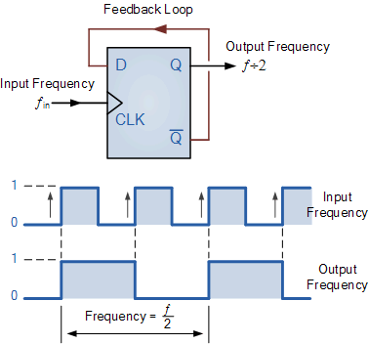

**Figure 1**

**Counters**

Flip flops can be used to form the basis for counters and registers. The counters are of two main types: **synchronous** and **asynchronous**. These flip flop and logic gates can be combined to produce different types of asynchronous counters. The Fig. 1 and Fig.2 illustrates the asynchronous and synchronous counter operation using JK flip-flop.

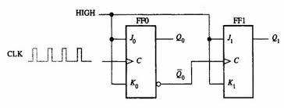

**Figure 1. Asynchronous Counter Operation using JK flip-flop**

Please see datasheet for details of the flip-flop.

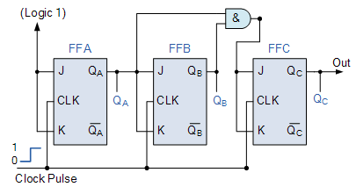

**Figure 2. Synchronous Counter Operation using JK flip-flop**

**Objective**

* To understand the concept and working of a synchronous and asynchronous counters (2, 3 and 4 bits) and to use IC 74LS76 JK flip flop for hardware implementation.
* To understand the concept and working of an asynchronous decade counters (BCD decade counter)

**Task # 1**

1. Consider the configuration of D flip flop shown below and draw the output (Fout) on page with respect to given clock pulse (Fin).

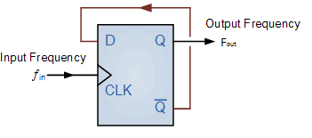

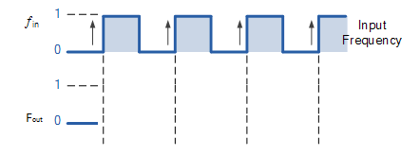

1. Find the relationship between input (Fin) and output frequency (Fout). Also, comment on relationship.
$F_{out}=fin/2$

2. Dry run the given circuit and fill the table below for given input.

|  |  |
| --- | --- |
| **fin** | **fout** |
| 1KHz | **500hz** |
| 500Hz | **250hz** |
| 200Hz | **100hz** |
|  |  |

1. Design the circuit on Circuit Maker and fill the table below

|  |
| --- |
|  |

|  |
| --- |
|  |

**Task # 2**

1. Consider the configuration of D flip flop shown below and draw the outputs (QA, QB and QC) **on page** with respect to given clock pulse (Fin).

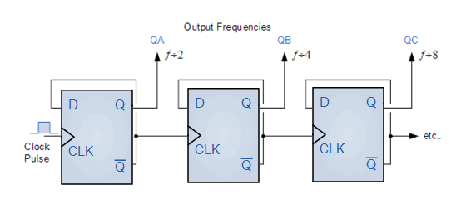

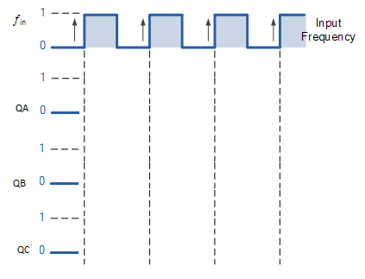

1. Find the relationship between input (Fin) and output frequency (Fout). Also, comment on relationship.
$QA= ___fin/2___$

$QB= __fin/4____$

$QC= ______fin/6$

2. Dry run the circuit and note the output frequencies

|  |  |  |  |
| --- | --- | --- | --- |
| **fin** | **QA** | **QB** | **QC** |
| 1KHz | **500hz** | 250hz | **125hz** |
| 500Hz | **250hz** | 125hz | **62.5hz** |
| 200Hz | **100hz** | 50hz | **25hz** |
|  |  |  |  |

1. Design the circuit on Circuit Maker and note the frequencies

|  |
| --- |
|  |

|  |
| --- |
|  |

|  |  |  |  |
| --- | --- | --- | --- |
| **fin** | **QA** | **QB** | **QC** |
| 1KHz | **500hz** | 250hz | **125hz** |
| 500Hz | **250hz** | 125hz | **62.5hz** |
| 200Hz | **100hz** | 50hz | **25hz** |
|  |  |  |  |

1. Implement the circuit on explorer board and note the frequencies

|  |
| --- |
| **Hardware Implementation** (Wave generated by explorer board) |

|  |  |  |  |
| --- | --- | --- | --- |
| **fin** | **QA** | **QB** | **QC** |
| 1KHz | **500hz** | 250hz | **125hz** |
| 500Hz | **250hz** | 125hz | **62.5hz** |
| 200Hz | **100hz** | 50hz | **25hz** |
|  |  |  |  |

1. Compare the result of software simulation and hardware implementation

**Task # 3**

1. Design and implement on Circuit Maker a 3-bit asynchronous binary up counter using JK flip-flop as 2-bit counter is illustrated in Fig. 1. Dry run, check and understand it’s working.

**Note 1.** Make sure flip flop should be working in **toggle mode** with **active high clock**.

**Note 2.** You can use two-way buttons in place of clock for testing purpose.

|  |
| --- |
| Circuit Maker Implementation. |

1. Fill the table shown below for the given clock pulse. Draw the wave form (on page) for $\underline{Q_{0}}$, $Q_{0 }, Q_{1}$ and $Q_{2}$. (paste Circuit Maker wave form here)

|  |
| --- |
| Timing diagram using Circuit Maker |

|  |  |  |  |
| --- | --- | --- | --- |
| Clock Pulse | Q2 | Q1 | Q0 |
| Initially | 0 | 0 | 0 |
| 1 | 0 | 0 | 0 |
| 2 | 0 | 0 | 1 |
| 3 | 0 | 1 | 0 |
| 4 | 0 | 1 | 1 |
| 5 | 1 | 0 | 0 |
| 6 | 1 | 0 | 1 |
| 7 | 0 | 1 | 1 |
| 8 | 1 | 1 | 1 |
| 9 | 0 | 0 | 0 |

1. What is the range (maximum number which can count) of the designed counter?

0-7

1. Find the clock pulse for recycle. (Where, **recycle** refers to the transition of counter from its final state to initial/original state.)

At 9

**Task # 4**

1. Design and implement on **Circuit Maker** a 4-bit asynchronous binary up counter using JK flip-flop. Dry run, check and understand it’s working.

|  |
| --- |
| Circuit Maker Implementation. |

1. Fill the table shown below for the clock pulse.

|  |  |  |  |  |
| --- | --- | --- | --- | --- |
| Clock Pulse | Q3 | Q2 | Q1 | Q0 |
| Initially | 0 | 0 | 0 | 0 |
| 1 | 0 | 0 | 0 | 1 |
| 2 | 0 | 0 | 1 | 0 |
| 3 | 0 | 0 | 1 | 1 |
| 4 | 0 | 1 | 0 | 0 |
| 5 | 0 | 1 | 0 | 1 |
| 6 | 0 | 1 | 1 | 0 |
| 7 | 0 | 1 | 1 | 1 |
| 8 | 1 | 0 | 0 | 0 |
| 9 | 1 | 0 | 0 | 1 |
| 10 | 1 | 0 | 1 | 0 |
| 11 | 1 | 0 | 1 | 1 |
| 12 | 1 | 1 | 0 | 0 |
| 13 | 1 | 1 | 0 | 1 |
| 14 | 1 | 1 | 1 | 0 |
| 15 | 1 | 1 | 1 | 1 |

1. What is the range (maximum number which can count) of the designed counter?

0-15

1. Find the clock pulse for recycle. (Where, **recycle** refers to the transition of counter from its final state to initial/original state.)

Initial

1. Fill the table shown below for the clock pulse.

|  |  |  |  |  |
| --- | --- | --- | --- | --- |
| Clock Pulse | Q3 | Q2 | Q1 | Q0 |
| Initially | 0 | 0 | 0 | 0 |
| 1 | 0 | 0 | 0 | 1 |
| 2 | 0 | 0 | 1 | 0 |
| 3 | 0 | 0 | 1 | 1 |
| 4 | 0 | 1 | 0 | 0 |
| 5 | 0 | 1 | 0 | 1 |
| 6 | 0 | 1 | 1 | 0 |
| 7 | 0 | 1 | 1 | 1 |
| 8 | 1 | 0 | 0 | 0 |
| 9 | 1 | 0 | 0 | 1 |
| 10 | 1 | 0 | 1 | 0 |
| 11 | 1 | 0 | 1 | 1 |
| 12 | 1 | 1 | 0 | 0 |
| 13 | 1 | 1 | 0 | 1 |

1. What is the range (maximum number which can count) of the designed counter?

0-13

1. Find the clock pulse for recycle. (Where, **recycle** refers to the transition of counter from its final state to initial/original state.)

Initial